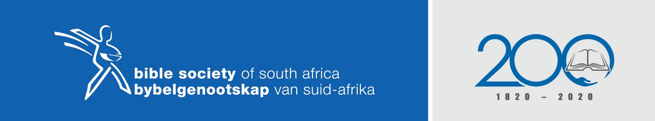
UHLAKA LWENTSHUMAYELO

NgokukaMathewu 5:2-12

Isihloko Sentshumayelo:
Izibusiso ezahlukeneyo

Amaphuzu entshumayelo:
- Izimo zokubusiswa nemiphumela emihle
- Ukuqhakambisa uthando nobuntu ekwenzeni okuhle
- Ukubaluleka kwezibusiso empilweni yemihla ngemihla
- Ukubekezela ngoKhristu kuzo zonke izimo

