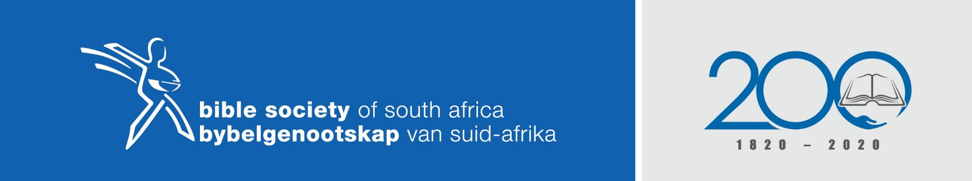
THEME FOR THE YEAR - THE BIBLE: HOPE FOR ALL

Sermon theme: The Word – Our compass to salvation and victorious living
Scripture reading: 2 Timothy 3:14-17
Objective/Summary: In the midst of the turmoil around us, the Bible remains constant and gives us wisdom to walk in salvation and to retain hope on the grounds of the infallible promises in the Bible.
Author: Francois Strydom (Pentecostal Protestant Church)

Sermon outline
In every facet of our life’s path, the Bible (Word of God) can accompany us in order to let us grow in His knowledge in order to equip us with power so that we will be able to bear good fruit.
- Diversity of God’s Word in the Scriptures
Paul advised Timothy to use the Scriptures as a foundation with a view of teaching, rebuking, correcting and training in righteousness. Why? (The following is a free translation of an unknown author of the “Sacred contents of the Bible”.)
The Bible contains the mind of God, the state of man, the way of salvation, the doom of sinners and the happiness of believers. (Colossians 1:9-11)
Its doctrines are holy, its precepts are binding, its histories are true, and its decisions are immutable. (Hebrews 4:12-13)
Read it to be wise, believe it to be safe, and practice it to be holy. It contains light to direct you, food to support you, and comfort to cheer you. (2 Timothy 2:15)
It is the traveller’s map, the pilgrim’s staff, the pilot’s compass, the soldier’s sword, and the Christian’s character. (Psalm 119:105)
Christ is its grand object; our good is its design, and the glory of God its end. It should fill the memory, rule the heart, and guide the feet. Read it slowly, frequently, and prayerfully. (John 1:1-5 & 14)
Here paradise is restored, Heaven opened, and the gates of hell disclosed. (John 4:14; Romans 10:8; 1 John 2:20)
It is given you in life and will be opened in the judgment and will be remembered forever. (John 12:47-48; Acts 17:11)
It involves the highest responsibility, will reward the greatest labour, and will condemn all who trifle with its sacred contents. (Matthew 22:29)
https://gracequotes.org/quote/this-book-contains-the-mind-of-god-the-state-of-m/

- Look at your situation through the lenses of God’s promises in the Word
As believers, we are exposed to testing and difficult times.
The enemy will endeavour to prevent God’s promises from coming to fruition.
If believers know God’s Word, we can, powerfully in God, take possession of that which belongs to us in faith. (2 Corinthians 1:20)
Like David, look at your giant through the lens of God’s promises – then this giant can become your greatest victory.
There are 1 260 recorded promises in the Word: thus 1 260 a year, 105 a month and 3,5 a day.
The crux of the message
- The Bible can provide direction for every challenge or situation in life.
- The Bible is, however, of little value if we are not acquainted with its contents.
- Just like the sun has never lost its power, the Word, has also remained living and active throughout all the centuries.
- The Bible contains all the elements as teaching to live a godly life.
- Through being in a relationship with Christ, the Word can become a 'Rhema' word for us and contain creation power. Without it, it is merely a 'Logos' word.
Therefore, even though the nations are turbulent around us, and we sometimes experience so many threats and uncertainties, the Word remains unchanged and unshakable. The circumstances may fade or wither, but his Word remains for ever. His Word drives out all fear. (Isaiah 40:8; 1 Peter 1:25)
Hint: Make the study of the Word of God your highest priority. Use a good Bible reading programme which can help you to read the Word of God meaningfully with comprehension and to internalise it. Studying God’s Word must be accompanied by earnest prayer.

